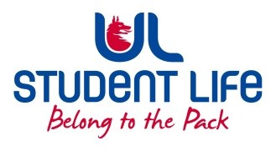UL Student Life

STUDENT EXECUTIVE COMMITTEE REPORT
Role / Position | : | Deputy President Welfare Officer
Author | : | Maeve
Date | : | 22/09/2022
Audience | : | UL Student Council Exec
Action | : | Approve
Goals
Main Goals |  |  | Progress (what have you achieved since the last Council meeting)
 |  |  | Welfare Wednesday was launched
 |  |  | Conversations with the Community Guard on how to work together on safety for students
 |  |  | Attended trainings such as safe talk and consent during the summer
 |  |  | In communication for drink testing kits for students
Other Achievements since last Council
 |  |  | Working with Management on a MH Strategy for the Organisation
Attendance at events/meetings and actions taken or agreed
 |  |  | GA, GA Finance, Healthy UL, Academic Council, started faculty board meetings, Community Liason Meeting, UL @ 50,
 |  |  | Upcoming: Healthy UL Mental Health, GA
Plans before the next meeting
Action/work area |  |  | What I hope to achieve
 |  |  | Link in with other Welfare Officers about plans for the year
 |  |  | Link in with Health Centre re Sexual Health
 |  |  | Finalise Mental Health plan for semester
Student Engagement
Type of Engagement (Meeting, event etc) |  |  | Purpose and anything to report on
 |  |  | Pop Ups in the Courtyard
 |  |  | Clubs and Socs Fair
 |  |  | Welfare Wednesday
 |  |  | Orientation tent talks
Media engagement and external relations
Engagement (Press, other organisations etc) |  |  | Purpose and anything to report on
 |  |  | N/A

