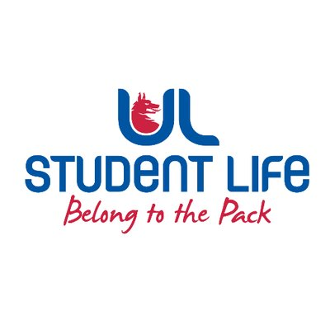
executive reports
UL STUDENT LIFE EXECUTIVE 2023/24
Role/Position: | Student Council Chairperson
Author: | Emma Wright
Date: | WK4 26/09/2023

Goals This Week |  | Action Required?
Welcome the Councillors | - First Council Meeting 3/10/23 | Reach out, recruit, represent.
Refine Social Plan | - To be voted at Council and action to be taken. | Work on event for 17/10.
Help Councillors understand their roles | - Collect data from Councillors | Collate data and discuss with LRO
Committee Meeting Updates |  | Action Required?
Updates since Last Council |  | Action Required?
Upcoming Plans: What I Hope to Achieve |  | Action
Engagement | Supporting Recruitment and continuously welcoming members to Council. | Recruitment Engagement
Plan 17/10/23 Social | I hope to work alongside Student Engagement and Events Reps to organise this outing, following from the first Council. | Create Social Events Team

