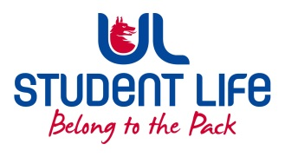
UL Student Life

STUDENT EXECUTIVE COMMITTEE REPORT
Role / Position | : | Student Council Chairperson
Author | : | Eoghan O’Mahony
Date | : | 15-11-22
Audience | : | UL Student Council
Action | :
Goals
Main Goals |  |  | Progress (what have you achieved since the last Council meeting)
Student Council |  |  | Chaired the Student Council Meeting week 10
Exec |  |  | Attended Exec in week 11 and 12 and brought student feedback and issues to both
LRO |  |  | Scheduled meeting with Jennifer around ways to increase awareness of council's discussions
ColC |  |  | Met with Ken Mooney from the Cost of living Coalition around creating a feedback chain between Council and the ColC.
Other Achievements since last Council

Attendance at events/meetings and actions taken or agreed
ColC Protest |  |  | Attended the Cost of Living protest in Limerick city to gauge issues impacting the greater limerick area.
Plans before the next meeting
Action/work area |  |  | What I hope to achieve
Student Engagement
Type of Engagement (Meeting, event etc) |  |  | Purpose and anything to report on
Media engagement and external relations
Engagement (Press, other organisations etc) |  |  | Purpose and anything to report on

