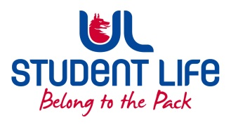
UL Student Life

STUDENT EXECUTIVE COMMITTEE REPORT
Role / Position | : | Societies Officer
Author | : | Katie
Date | : | 23/2/2023
Audience | : | UL Student Council Exec
Action | : | Approve
Goals
Main Goals |  | Progress (what have you achieved since the last Council meeting)
Working Evening |  | Iron out issues with engagement, re-education, resources etc.
Other Achievements since last Council
C&S Exec |  | Awards hustings drop ins  Planning at peer-to-peer workshops and drop ins
 |  | Special Applications - Approval of applications from Clubs and Socs and encouraging others to apply for funding
External Engagement |  | C&S Alumni Working Group
 |  | Spoke at PSU Council about postgrad engagement, lots of very valuable feedback to work on
 |  | Met with Paul Lee about developing event ideas and engagement plans
Attendance at events/meetings and actions taken or agreed
 |  | Attended C&S Exec, UL Student Exec, C&S Council, Student Council, PSU Council, Fem Soc Vigil
Plans before the next meeting
Action/work area |  | What I hope to achieve
Education |  | Continue to educate and inform the Wolves community of rules, roles etc.
Engagement |  | Meet with PSU Academic Officer Vivin to discuss feedback
Student Centre |  | Updates and information
Student Engagement
Type of Engagement (Meeting, event etc) |  | Purpose and anything to report on
Email |  | Societies Officer email address for direct contact with members
Media engagement and external relations
Engagement (Press, other organisations etc) |  | Purpose and anything to report on
WhatsApp Group |  | Updates and encouraging socs to introduce themselves and share events
 |  | Sharing Socs good news weekly

