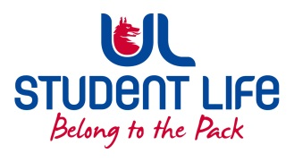
UL Student Life

STUDENT EXECUTIVE COMMITTEE REPORT
Role / Position | : | PSU Rep.
Author | : | Louis Pemble
Date | : | 06-10-22
Audience | : | UL Student Council
Action | :
Goals
Main Goals |  |  | Progress (what have you achieved since the last Council meeting)
Better Timetables |  |  | Met with Fintan Breen. WG has begun, consultation with stakeholders expected semester 2.
Student Accommodation |  |  | After discussion at Exec we will explore what is possible and bring this to council.
Better Transport Links |  |  | Chased up one way system idea.
i-grade reform |  |  | Waiting for update at ARC
Funding for Eist |  |  | Chased up final decision.
Other Achievements since last Council

Events |  |  | Halloween and Diwali events being advertised.
Attendance at events/meetings and actions taken or agreed
C&S Council |  |  | Attended.
Plans before the next meeting
Action/work area |  |  | What I hope to achieve
Bus Route |  |  | Letter written
Student Engagement
Type of Engagement (Meeting, event etc) |  |  | Purpose and anything to report on
Courtyard |  |  | Chatted with students
Student Walkout |  |  | Strongly attended.
UG warm up |  |  | I received a call from SL reception saying they had a cold wet student in need of our facilities. I welcomed the student to PSU, but I would suggest SL need to urgently review what they are offering coming up to winter.
Media engagement and external relations
Engagement (Press, other organisations etc) |  |  | Purpose and anything to report on
USI, Minister |  |  | Postgrad VP met with Minister Harris and USI.

