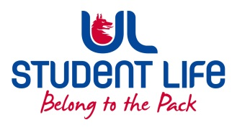
UL Student Life

STUDENT EXECUTIVE COMMITTEE REPORT
Role / Position | : | Faculties Officer
Author | : | Niamh Hickey
Date | : | 16/11/2022
Audience | : | UL Student Council Executive/UL Student Council
Action | : | Approve
Goals
Main Goals |  |  | Progress (what have you achieved since the last Council meeting)
Student Recruitment |  |  | - Spoke to students privately about Student Council, attended the Class Rep Forum, encouraged students to join Student Council.
Student Training |  |  | - Spoke about NStEP training at the Class Rep Forum
Student Feedback |  |  | - Class Rep Group Chats up and running.
Other Achievements since last Council
Training |  |  | n/a
Attendance at events/meetings and actions taken or agreed
Meetings |  |  | - 3 Further Student Executive meetings as of this report.  - Raised the issue of students being penalised for not attending classes.  1 Council meeting in Week 10  - Brought up the work that I’ve been doing as Faculties Officer and NStEP (National Student Engagement Programme) training to councillors.
Events |  |  | - Attended the Class Rep Forum in Week 11  - Attended multiple Commuter Hub Mornings
Plans before the next meeting
Action/work area |  |  | What I hope to achieve
Meetings |  |  | - Discuss further the lack of facilities open over the weekend on campus & students being penalised over not attending lectures
Student Recruitment |  |  | - Discuss further the article in Limerick Voice about student recruitment
Student Feedback |  |  | - Help to act on the information given by students at the Student Forum
Student Engagement
Type of Engagement (Meeting, event etc) |  |  | Purpose and anything to report on
Event |  |  | - Class Rep Forum, spoke about Student Council vacancies
Meeting |  |  | - n/a
Media engagement and external relations
Engagement (Press, other organisations etc) |  |  | Purpose and anything to report on
Press |  |  | - Photograph taken in the Commuter Hub by the Examiner

