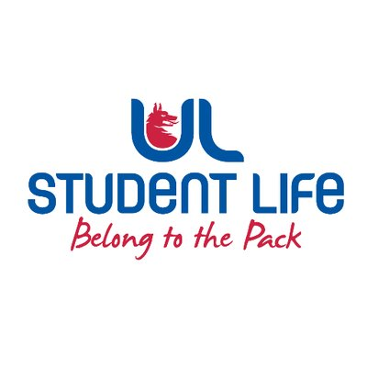
executive reports
UL STUDENT LIFE EXECUTIVE 2023/24
Role/Position: | Student Events Chairperson
Author: | Todor Aleksandrov
Date: | WK6 16/10/23

Goals This Week |  | Action Required?
Events | - Finalise student council event | Meeting
Class reps | - Go around campus recruiting reps | Recruitment
Committee Meeting Updates |  | Action Required?
Student council | Raised accessibility on campus as an issue | N/A
Updates since Last Council |  | Action Required?
Meetings | Met with Events coordinators to see how I can help with upcoming events
Events | Organising an event for student council | N/A
Student Engagement | Helped recruit class reps | N/A
Upcoming Plans: What I Hope to Achieve |  | Action
Merch | Push for some SC and executive merch | Advocate
Accessibility | Improve accessibility and flow of people on campus | Add it to the agenda

