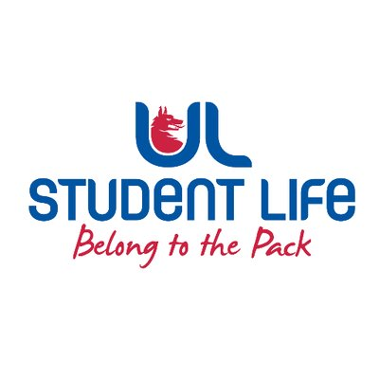
executive reports
UL STUDENT LIFE EXECUTIVE 2023/24
Role/Position: Student President
Author: Ronan Cahill
Date: | WK4 12/10/2023

Goals This Week |  | Action Required?
Cost of Living Coalition | - Demonstration was carried out successfully in Dublin with 31 Students attending. Was absolutely fantastic to fulfil the Mandate passed over from last year’s Studetn Council and Officer team to demonstrate in light of the ongoing Cost of Living Crisis and Accommodation Crisis. Richard Boyd Barrett TD Leader of the People Before Profit party and leader of the cost of living coalition expressed his thanksat the rally for the UL Student Unions who attended which was fantastic. It was a brilliant day for both unions on campus showing that Student Activism is well and truly alive again in UL. This was also a big thing in my manifesto to raise the lack of accommodation on national level and so to lead the UL Students to a national protest and express these view in an interview for Virgin Media Ireland at the protest was important in ensuring the voice of UL Students in heard!
Commuter Hub | - Continue to lead organisation on the Commuter Hub, have now got a list of volunteers interested in helping out at the Commuter Hub and I will reach out to them in organising training around volunteering at the Commuter Hub. I wil also do a stock check and ensure we have enough stock for the next week and I will continue ensuring the fresh milk is in stock and available for the next week.
Committee Meeting Updates |  | Action Required?
GA | First meeting of the 6th Governing Authority was held last Sunday. We are still in the process of electing a chancellor which will then allow us to start functioning as a Governing Body.
Arts Faculty Board Meeting | Healthy UL presented at the start of the meeting where they informed us about the new Student Bike Rental scheme which they have introduced which is a great opportunity for students to avail of renting a bike to allow them to commute around to and from college and around the area.
Updates since Last Council |  | Action Required?
Training | N/A | N/A
Meetings | Met with Stables Management about introduction of Anti-Spiking measures and posters along with Harm Reduction posters around stables. Also talked about the possibility of Harm Reduction table being present at Techno Tuesday and other events in the stables. Also asked about purchasing Meal Vouchers which I will be giving out to students for free during my Officers on The Ground Initiative which I want to get running next week | Design Meal Vouchers to give to Students. Link Emily in with Stables Management around introduction of Harm Reduction Table
Events | N/A
Student Engagement | N/A | N/A
Media and Public Relations | Interview with Virgin Media News at the Cost of Living Coalition Pre-Budget Protest where I emphasised again the need for an immediate plan of investment for student accommodation infrastructure in Limerick. I also highlighted that in Ireland we have some of the highest third level fees for education in Ireland and that this needs to be addressed. Did a similar Interview with Dublin Live. | N/A
Upcoming Plans: What I Hope to Achieve |  | Action
Accessibility Issues | Working with Buildings and Estates and Katie(Communities Officer) in addressing accessibility issues on campus and will receiving a full report on issues we have highlighted. | Follow up with buildings and estates on report
Traffic Issues | Also working with Student Executive and liaising with Buildings and Estates in looking at alternative traffic solutions to alleviate traffic and conjestion on campus for students.

