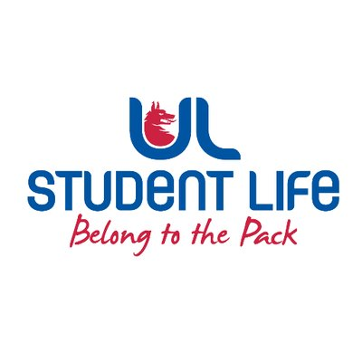
executive reports
UL STUDENT LIFE EXECUTIVE 2023/24
Role/Position: Faculties Officer
Author: Niamh Hickey
Date: | WK3 28/09/2023

Goals This Week |  | Action Required?
Student Council Handbook | Help Emma work on the Student Council Handbook | Work on the Canva doc with Emma
Committee Meeting Updates |  | Action Required?
n/a | n/a | n/a
Updates since Last Council |  | Action Required?
Training | Chairperson Training during the summer | n/a
Meetings | Meetings with Jasmine and Ronan M during the summer on recruitment | n/a
Events | n/a | n/a
Student Engagement | Chatting and emailing students about becoming class and student council reps, going well so far  Working on issues with School of Engineering re: Deleting past papers off of Sharepoint | n/a
Media and Public Relations | n/a | n/a
Upcoming Plans: What I Hope to Achieve |  | Action
Demonstration | Help out with organising protest and making signs/tshirts
Student Council Handbook | Working on the Canva Doc

