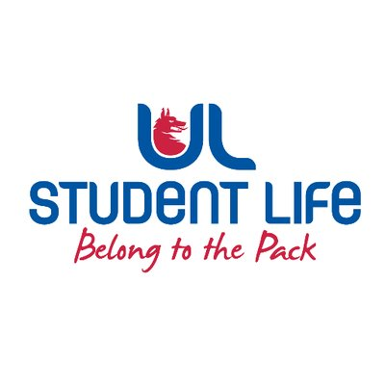
executive reports
UL STUDENT LIFE EXECUTIVE 2023/24
Role/Position: Faculties Officer
Author: Niamh Hickey
Date: | WK11 22/11/2023 (Submitted late due to illness)

Goals This Week |  | Action Required?
Motion | Bring motion to Council in Week 12 on ERB requirements, this is based on feedback gathered at council | Work on motion with LRO
Story board | Work on videos for ULSL social media – based on becoming a class rep. | Plan & shoot video
Committee Meeting Updates |  | Action Required?
Exec | Briefed Exec on the motion that I plan on bringing to Council in Week 12 | n/a
Updates since Last Council |  | Action Required?
Training | n/a | n/a
Meetings | Exec and Council meetings attended, attending AHSS Faculty Board meeting this week as well. | n/a
Events | Planning on attending the Council Xmas Event | n/a
Student Engagement | Reached out to new Faculty Reps, plan on emailing department councillors before exams | n/a
Media and Public Relations | n/a | n/a
Upcoming Plans: What I Hope to Achieve |  | Action
Council | Bring motion to council re: ERB requirements | n/a

