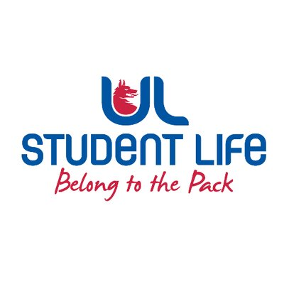
executive reports
UL STUDENT LIFE EXECUTIVE 2023/24
Role/Position: Faculties Officer
Author: Niamh Hickey
Date: | WK9 8/11/2023 (Submitted late due to bereavement)

Goals This Week |  | Action Required?
Exec | Work on feedback gained from exec item (Candidate Requirements for Election) | Work on feedback
Committee Meeting Updates |  | Action Required?
Exec | Brought item to exec on candidate requirements for election, | n/a
Updates since Last Council |  | Action Required?
Training | Facilitated NStEP Training | n/a
Meetings | Exec and Council meetings attended | n/a
Events | n/a | n/a
Student Engagement | n/a | n/a
Media and Public Relations | n/a | n/a
Upcoming Plans: What I Hope to Achieve |  | Action
Exec Item | Continue working on feedback from Exec, work with exec members to recruit class reps | n/a

