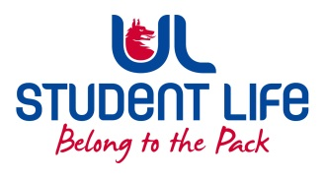
UL Student Life

STUDENT EXECUTIVE COMMITTEE REPORT
Role / Position | : | Equality and Diversity Chairperson
Author | : | Vivin Viswanath
Date | : | 22nd November 2021
Audience | : | UL Student Council
Action | : | Draft
Goals
Main Goals |  |  | Progress (what have you achieved since the last Council meeting)
Action points on Feminist & LGBTQ interest groups |  |  | Discussed with Jordon regarding converting one handicapped-person toilet in each building to gender-neutral one.
Other Achievements since last Council
NA
Attendance at events/meetings and actions taken or agreed
Global Café: Diversity Week |  |  | Assisted in organizing Global café event in Pavilion.
Councillors meet-up |  |  | Carried out meeting with councillors on 12th November to understand work they had been carrying out till now and the future goals they have set.
Plans before the next meeting
Action/work area |  |  | What I hope to achieve
Disabilities support |  |  | Enhancing ASD facilities in campus and increasing awareness on the same.
Student Engagement
NA
Media engagement and external relations
NA

