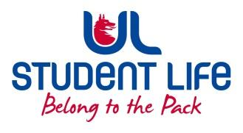
UL Student Life

STUDENT EXECUTIVE COMMITTEE REPORT
Role / Position | : | Experience Chairperson
Author | : | Deepak Venkatasuresh
Date | : | 24 March 2022
Audience | : | UL Student Council
Action | : | Approve
Goals
Main Goals |  |  | Progress (what have you achieved since the last Council meeting)
ULSL Elections |  |  | Helped increase the voter turn out by asking students to vote on the election day.
Other Achievements since last Council

N/A
Attendance at events/meetings and actions taken or agreed
Plans before the next meeting
Action/work area |  |  | What I hope to achieve
Student Engagement
Type of Engagement (Meeting, event etc) |  |  | Purpose and anything to report on
Media engagement and external relations
Engagement (Press, other organisations etc) |  |  | Purpose and anything to report on

