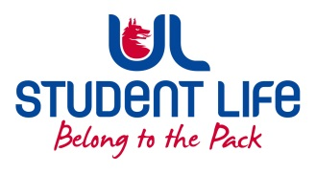
UL Student Life

STUDENT EXECUTIVE COMMITTEE REPORT
Role / Position | : | Academic Officer
Author | : | Kieran Guiry
Date | : | 03/11/2022
Audience | : | UL Student Council
Action | : | Approve
Goals
Main Goals |  |  | Progress (what have you achieved since the last Council meeting)
Student Rep Recruitment |  |  | 132 Class reps now recruited as of Week 6.
Other Achievements since last Council
Attendance at events/meetings and actions taken or agreed
SLOS |  |  | Working group on UG first year start
KBS Faculty Board |  |  | Encouraged dept to try and emphasise to students the importance of class reps.
ULTAC |  |  | Discussed the actions to be taken place with the roll out of bright space
Plans before the next meeting
Action/work area |  |  | What I hope to achieve
Review student forum feedback |  |  | As a team will review the feedback left by the students.
Student Engagement
Type of Engagement (Meeting, event etc) |  |  | Purpose and anything to report on
Social Media
Email |  |  | Supported 21 students over email this last 2 weeks. Most common topic was Course transfers / exit queries.
Pop-ups
Student meetings |  |  | Met with 2 class reps to discuss issues around modules
Media engagement and external relations
Engagement (Press, other organisations etc) |  |  | Purpose and anything to report on
 |  |  | Preparing for a campaign around dealing with stress around exam time

