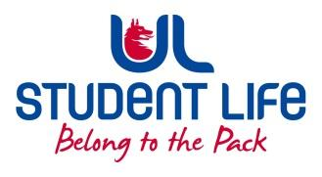
UL Student Life

STUDENT EXECUTIVE COMMITTEE REPORT
Role / Position | : | Experience Chairperson
Author | : | Deepak Venkatasuresh
Date | : | 14 March 2022
Audience | : | UL Student Council
Action | : | Approve
Goals
Main Goals |  |  | Progress (what have you achieved since the last Council meeting)
Meeting with Noreen from CO-OP |  |  | Had a meeting with Noreen along with CO-OP councillor Qin, informed about student feedback received during student forum. Had a discission for an hour, providing suggestions on how to improve the CO-OP facility for students.
Other Achievements since last Council

N/A
Attendance at events/meetings and actions taken or agreed
Plans before the next meeting
Action/work area |  |  | What I hope to achieve
Student Engagement
Type of Engagement (Meeting, event etc) |  |  | Purpose and anything to report on
Meeting with Alice |  |  | Met with Alice to discuss further about CO-OP.
Media engagement and external relations
Engagement (Press, other organisations etc) |  |  | Purpose and anything to report on

