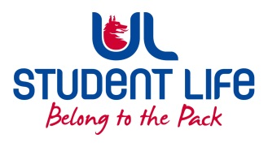
UL Student Life

STUDENT EXECUTIVE COMMITTEE REPORT
Role / Position | : | Equality and Diversity Chairperson
Author | : | Vivin Viswanath
Date | : | 10th March 2022
Audience | : | UL Student Council
Action | : | Draft
Goals
Main Goals |  |  | Progress (what have you achieved since the last Council meeting)
Fundraising event |  |  | Fundraiser events were proposed by the Disabilities Councillor from raising money for Down Syndrome Ireland (DSI).  The event is proposed to have a small stall setup in Student Life courtyard or in front of Main building. The stall will be selling books, cookies or other items meant to raise money for the donation.  In discussion with Dara and Cillian on the formalities for the same.
Other Achievements since last Council
NA
Attendance at events/meetings and actions taken or agreed
Meeting with Councillor |  |  | Conducted meeting with Disabilities councillor w.r.t the fundraisers and future events.
Plans before the next meeting
Action/work area |  |  | What I hope to achieve
NA
Student Engagement
NA
Media engagement and external relations
NA

