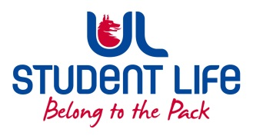
UL STUDENT LIFE

STUDENT EXECUTIVE COMMITTEE REPORT
Role / Position | : | Societies Officer
Author | : | Jeremy Pili
Date | : | 21 October 2021
Audience | : | UL Student Council
Action | : | Update & Opinion
Goals
Main Goals |  |  | Progress since the last Council meeting
Society-Wide Communication |  |  | Poll sent out to all societies committees, waiting on responses for the next week or two until making a decision.
Public Relations Supports for all C&S |  |  | Drafting proposal for a common creative suite for C&S committees, will pose to C&S Exec when finalised.
Other Achievements since last Council

Philosophy and Debating Society Setup |  |  | Answered questions from the interim committee in regards to focus and events, reviewed in-progress proposal documents sent to me and provided feedback as necessary.
Attendance at events/meetings and actions taken or agreed
C&S Executive |  |  | Voiced opinions on gear gifting from a societies point of view,
Plans before the next meeting
Action/work area |  |  | What I hope to achieve
Survey on Society Struggles & Sentiments |  |  | Getting a feel for what societies are in requirement of and their opinions of C&S as a whole, as well as encouraging their participation in C&S Council and availing of support schemes from the Office; i.e. Special Apps, Health Checks etc.
Student Engagement
Type of Engagement (Meeting, event etc) |  |  | Purpose and anything to report on
In-Person Conversations |  |  | Gained insight into problems faced by society committees.  Heard from Computer Society and ULFM; woes surrounding venue availability and inquiries into the Wolves Strategic Fund.
Media engagement and external relations
Engagement (Press, other organisations etc) |  |  | Purpose and anything to report on
N/A

