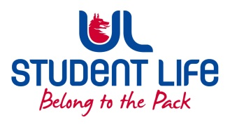
UL Student Life

STUDENT EXECUTIVE COMMITTEE REPORT
Role / Position | : | Academic Officer
Author | : | Kieran Guiry
Date | : | 20/10/2021
Audience | : | UL Student Council
Action | : | Approve
Goals
Main Goals |  |  | Progress (what have you achieved since the last Council meeting)
Student Rep Recruitment |  |  | 96 Class reps now recruited as of Week 6.
Student Forums |  |  | I attended the student Forum on Wednesday evening..  Got some great feedback on different topics from the students  We as a team will now review the feedback.
Power in old part of library |  |  | Following up on a student report of a lot of desks in the old part of the lib without power
Other Achievements since last Council
 |  |  | Hosted a successful Don’t drop out, Drop in campaign
Attendance at events/meetings and actions taken or agreed
NStEP training |  |  | Attended NStEP training on Wed 13th
S+E Faculty Board |  |  | Encouraged dept to try and emphasise to students the importance of class reps.
Co-op Office |  |  | I met with the co-op office to speak to them and figure out ways we can assist one another throughout the year.
Plans before the next meeting
Action/work area |  |  | What I hope to achieve
Review student forum feedback |  |  | As a team will review the feedback left by the students.
Student Engagement
Type of Engagement (Meeting, event etc) |  |  | Purpose and anything to report on
Social Media
Email |  |  | Supported 17 students over email this week. Most common topic was Course transfers / exit queries.
Pop-ups
Student meetings |  |  | Hosted a Don’t drop out, drop in. drop in, where we made a space for students to call in and talk about their options.
Media engagement and external relations
Engagement (Press, other organisations etc) |  |  | Purpose and anything to report on

