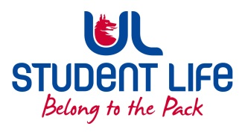
UL Student Life

STUDENT EXECUTIVE COMMITTEE REPORT
Role / Position | : | Equality and Diversity Chairperson
Author | : | Vivin Viswanath
Date | : | 21-10-2021
Audience | : | UL Student Council
Action | : | Draft
Goals
Inclusion of Feminist & LGBTQ interest groups |  |  | The primary aim set now is to focus on the concerns reported by Feminist & LGBTQ groups in UL.
Other Achievements since last Council
 |  |  | Discussed with E&D counsellor regarding the same and mailed to the interest group contacts on the same. Awaiting further updates on this from their end.
Attendance at events/meetings and actions taken or agreed
Meeting organized with Feminist & LGBTQ leads |  |  | Meeting was organized with the Feminist & LGBTQ SPOCs and discussed on their feedbacks/views.
Plans before the next meeting
Create a POC for Feminist & LGBTQ group |  |  | Plan is to create a point of contact from both Feminist and LGBTQ groups who will report the Student Exec member for any issues, suggestions they have discussed within their internal groups and needs to be addressed in a larger platform.
Student Engagement
N.A
Media engagement and external relations
N.A

