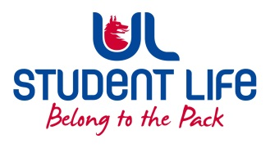
UL Student Life

STUDENT EXECUTIVE COMMITTEE REPORT
Role / Position | : | Clubs Officer
Author | : | Mary O’Donnell
Date | : | 20/10/2021
Audience | : | UL Student Council
Action | : | Approve
Goals
Main Goals |  |  | Progress (what have you achieved since the last Council meeting)
Establish contact with other clubs |  |  | Sent out introduction email to all clubs to let other committees aware of my position and what I can offer
Other Achievements since last Council
n/a
Attendance at events/meetings and actions taken or agreed
Exec Meeting |  |  | Inputted on Accommodation crisis
C&S Meeting |  |  | Approved Hockey Club
Chairperson Training |  |  | Learned important Chairperson skills and how to manage meetings effectively
Plans before the next meeting
Action/work area |  |  | What I hope to achieve
Team Bonding |  |  | Get to know the rest of the exec team better!
Admin Seminar |  |  | Learn how to improve my admin skills and how to be a more efficient committee member
Student Engagement
Type of Engagement (Meeting, event etc) |  |  | Purpose and anything to report on
OPC Email |  |  | Discussed with OPC President the honorary members process – brought to C&S and will continue discussion in C&S Exec
Media engagement and external relations
Engagement (Press, other organisations etc) |  |  | Purpose and anything to report on
n/a

