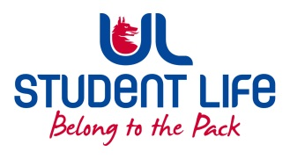
UL Student Life

STUDENT EXECUTIVE COMMITTEE REPORT
Role / Position | : | Postgrad Rep
Author | : | Louis Pemble
Date | : | 25.02.22
Audience | : | UL Student Council
Action | :
Goals
Main Goals |  |  | Progress (what have you achieved since the last Council meeting)
PSU Upgrades |  |  | Work approved for Berko boiler, waiting for dates. Waiting for update on doors
Timetables |  |  | Expectations relayed to Academic Registry.
Postgrad month |  |  | In full swing. Great engagement and connections made.
Postgrad Ball |  |  | Dates are being discussed. Quote received from prospective venue
Exit Awards |  |  | Students being charged for Masters when leaving pre thesis.
PhD Fees |  |  | Discussed solutions with GPS who are reviewing.
PhD Society |  |  | Proposal written, to be submitted next week.
Attendance at events/meetings and actions taken or agreed
C&S Council |  |  | Reshaping C&S Exec
Ceremonies and Alumni Office |  |  | Celebratory events announced for April.
Policy Reviews |  |  | Agreement in principle to change comments such as ‘the students union’ to ‘your students union’ in UL policy docs
Plans before the next meeting
Action/work area |  |  | What I hope to achieve
UL at 50 |  |  | Proposals made
GPS |  |  | PSU to give talks at open days.
Student Engagement
Type of Engagement (Meeting, event etc) |  |  | Purpose and anything to report on
UG Students |  |  | Requests from UG students for microwaves to be available in SL.
Poster Campaign |  |  | Posters to be printed and hung around campus
Student meetings |  |  | Numerous meetings with students
Media engagement and external relations
Engagement (Press, other organisations etc) |  |  | Purpose and anything to report on
Spotify |  |  | Singo Bingo Playlist now available

