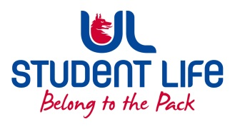
UL Student Life

STUDENT EXECUTIVE COMMITTEE REPORT
Role / Position | : | Equality and Diversity Chairperson
Author | : | Vivin Viswanath
Date | : | 24th February 2022
Audience | : | UL Student Council
Action | : | Draft
Goals
Main Goals |  |  | Progress (what have you achieved since the last Council meeting)
Pride events |  |  | Pride pizza evening was conducted on 21st February. Interacted with ‘Out in UL’ group members to understand their concerns and feedback.
Other Achievements since last Council
NA
Attendance at events/meetings and actions taken or agreed
Pride events |  |  | Attended Pride pizza evening on 21st February.
Plans before the next meeting
Action/work area |  |  | What I hope to achieve
NA
Student Engagement
LGBTQ Survey |  |  | One of the members in ‘Out In UL’ presented a plan to survey the feedback of LGBTQ members in entire UL. Though this proposal is in very preliminary stage but it is worth pursuing after assessing feasibility.
Media engagement and external relations
NA

