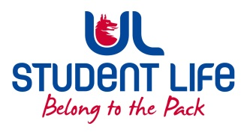
UL Student Life

STUDENT EXECUTIVE COMMITTEE REPORT
Role / Position | : | Postgrad Rep
Author | : | Louis Pemble
Date | : | 12.10.21
Audience | : | UL Student Council
Action | : | Approve
Goals
Main Goals |  |  | Progress (what have you achieved since the last Council meeting)
Speak Out Tool |  |  | Supported important initiative and took part in filming
Return to campus |  |  | Advocated for study spaces, events.
Student Cards |  |  | C. 400 postgrads did not receive cards due to system error. Corrected by GPS
Face Masks |  |  | All PG students can collect a box of face masks from our common room
Accommodation |  |  | Waiting for Exec plan
PhD Fees |  |  | Met with NUIG SU to put together a case study.
Attendance at events/meetings and actions taken or agreed
camgG |  |  | Additional study space advertised in empty classrooms
Student engagement coordinator |  |  | Met to discuss possible collaborations
Plans before the next meeting
Action/work area |  |  | What I hope to achieve
Compensating grades |  |  | Clarity on how things will work once these are removed.
More events |  |  | All events for this semester booked.
PhD fees |  |  | Contact more SU’s.
Student Engagement
Type of Engagement (Meeting, event etc) |  |  | Purpose and anything to report on
Cricket Event |  |  | Function planned in Pavilion
PSU Council and Exec |  |  | Pizza lunch for members last week
Halloween Event |  |  | Being planned for Thursday before Halloween
Student meetings |  |  | Students can now book meetings with VP and P through psu website
Media engagement and external relations
Engagement (Press, other organisations etc) |  |  | Purpose and anything to report on
An Focal |  |  | Interview on Accommodation Crisis

