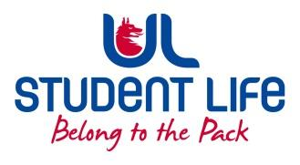
UL Student Life

STUDENT EXECUTIVE COMMITTEE REPORT
Role / Position | : | Experience Chairperson
Author | : | Deepak Venkatasuresh
Date | : | 10 February 2022
Audience | : | UL Student Council
Action | : | Approve
Goals
Main Goals |  |  | Progress (what have you achieved since the last Council meeting)
Meeting with interest group councillors |  |  | Had a meeting with my interest group councillors on Wednesday. Had a major discussion about co-op and other issues.
Other Achievements since last Council

N/A
Attendance at events/meetings and actions taken or agreed
Plans before the next meeting
Action/work area |  |  | What I hope to achieve
To work on the issues discussed during interest group meeting |  |  | Will take the information discussed during the interest group council meeting to exec meeting to discuss and decide on how to work further on these issues.
Student Engagement
Type of Engagement (Meeting, event etc) |  |  | Purpose and anything to report on
Media engagement and external relations
Engagement (Press, other organisations etc) |  |  | Purpose and anything to report on

