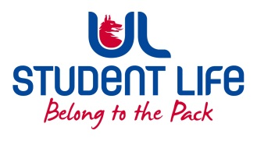
UL Student Life

STUDENT EXECUTIVE COMMITTEE REPORT
Role / Position | : | Equality and Diversity Chairperson
Author | : | Vivin Viswanath
Date | : | 10th February 2022
Audience | : | UL Student Council
Action | : | Draft
Goals
Main Goals |  |  | Progress (what have you achieved since the last Council meeting)
Pride week on Week#5 |  |  | Involved in meetings with Jordan, Dara and Out In UL group for the discussion on Pride Week.  Events planned so far include Pride pizza evening, Drag & Karaoke show etc. Final list of events and merchandizes will be confirmed in Week 4.
Other Achievements since last Council
NA
Attendance at events/meetings and actions taken or agreed
NA
Plans before the next meeting
Action/work area |  |  | What I hope to achieve
Pride Week |  |  | List of confirmed events, merc and activities for the Pride Week.
Student Engagement
NA
Media engagement and external relations
NA

