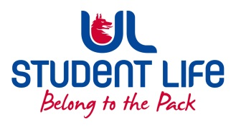
UL Student Life

STUDENT EXECUTIVE COMMITTEE REPORT
Role / Position | : | Clubs Officer
Author | : | Mary O’Donnell
Date | : | 09/02/2022
Audience | : | UL Student Council
Action | : | Approve
Goals
Main Goals |  |  | Progress (what have you achieved since the last Council meeting)
Election Promotion |  |  | Contacted Chairpersons about promoting voting in their clubs
RAG week |  |  | Contacted Chairpersons about promoting RAG week events and fundraisers within their clubs
Other Achievements since last Council
Slack Channels |  |  | Discussions on Club Branding, Approving MedSoc Special App
Attendance at events/meetings and actions taken or agreed
C&S Meeting |  |  | Aeronautical and People Before Profit Approval, input on role in exec
Plans before the next meeting
Action/work area |  |  | What I hope to achieve
 |  |  | Helping Siobhan promote exec
Student Engagement
Type of Engagement (Meeting, event etc) |  |  | Purpose and anything to report on
Astronomy |  |  | Organising Varsities – filling out documentation
Swim Club |  |  | 10yr Anniversary arrangements, helping with Special App, Swim EGM attended
Media engagement and external relations
Engagement (Press, other organisations etc) |  |  | Purpose and anything to report on

