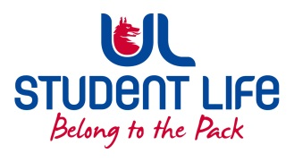
UL Student Life

STUDENT EXECUTIVE COMMITTEE REPORT
Role / Position | : | Postgrad Rep
Author | : | Louis Pemble
Date | : | 22.11.21
Audience | : | UL Student Council
Action | :
Goals
Main Goals |  |  | Progress (what have you achieved since the last Council meeting)
Speak Out Tool |  |  | Have started to direct students to this
Return to campus |  |  | Moving as many assessments online as possible. Providing provisions around this.
Events |  |  | Scaling back events in line with Covid surge
Face Masks |  |  | Reminder that these are still available to collect.
Accommodation |  |  | No updates from management, concerns remain.
PhD Fees |  |  | Plan to be presented to faculties.
International services |  |  | Met with Provost, VP Global and UL Global
Attendance at events/meetings and actions taken or agreed
Global Cafe |  |  | Excellent event from Student Communities. Great opportunity for listening and engagement.
Students |  |  | Discussed semester two with various student groups.
ADAA EHS |  |  | Discussion around online learning.
Plans before the next meeting
Action/work area |  |  | What I hope to achieve
Christmas for kids of UL |  |  | Final decision on plan for festivities.
PG Month |  |  | Firm up plans for postgrad month.
PhD Society |  |  | Work going into fulfilling C&S requirements.
Student Engagement
Type of Engagement (Meeting, event etc) |  |  | Purpose and anything to report on
PME Class Reps. |  |  | Regular contact with class group as arrangements are made for next semester.
Ceremonies |  |  | Discussion around January Conferring and April Celebratory Event
Media engagement and external relations
Engagement (Press, other organisations etc) |  |  | Purpose and anything to report on

