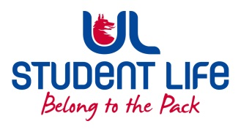
UL Student Life

EXECUTIVE COMMITTEE REPORT
President
Author | : | Alan Enright (Faculties Officer)
Date | : | 19/11/2021
Audience | : | Student Council
Action | : | Approve
Goals
Main Goals |  |  | Progress (what have you achieved since the last AGM)
 |  |  | To pinpoint areas where representation is lacking, will go through list of reps and documented what years and what courses are currently lacking representation.
Assess ongoing issues with FYP tutors.
 |  |  | Reached out to class reps and other council members in relation to current student representation methods and opinions on efficiency etc.
 |  |  | Determine a method of representation for students who aren’t taking prescribed courses and are picking their own subjects etc.
Other Achievements since last Council
 |  |  | Performance nerds leadership training
 |  |  | Attended class rep forum
Attendance at events/meetings and actions taken or agreed
 |  |  | Class rep forum, Emergency council
Plans before the next meeting
Action/work area |  |  | What I hope to achieve
 |  |  | Improve / increased number of groups / courses represented.
 |  |  | Attend board of directors of ULSL meeting.
Student Engagement
Type of Engagement (Meeting, event etc) |  |  | Purpose and anything to report on
Media engagement and external relations
Engagement (Press, other organisations etc) |  |  | Purpose and anything to report on
 |  |  | n/a

