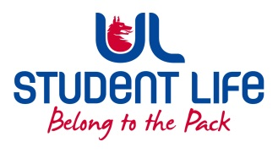
UL Student Life

STUDENT EXECUTIVE COMMITTEE REPORT
Role / Position | : | Student Experience Chairperson
Author | : | Deepak Venkatasuresh
Date | : | 18 November 2021
Audience | : | UL Student Council
Action | : | Approve
Goals
Main Goals |  |  | Progress (what have you achieved since the last Council meeting)
Other Achievements since last Council
Meeting with Councillors |  |  | Met with my councillors and got a lot of information and shared it with other executives during the weekly executive meeting out of which the problems faced in the co-op office were discussed as an issue where some action must be taken.
Attendance at events/meetings and actions taken or agreed
Emergency Meeting |  |  | Attended the emergency meeting to discuss about the gates being constructed at kemmy.
Plans before the next meeting
Action/work area |  |  | What I hope to achieve
Councillors |  |  | Trying to recruit councillors for my interest group.
Student Engagement
Type of Engagement (Meeting, event etc) |  |  | Purpose and anything to report on
Nil
Media engagement and external relations
Engagement (Press, other organisations etc) |  |  | Purpose and anything to report on
Nil

