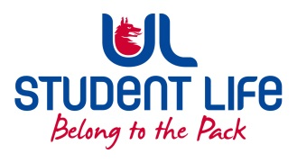
UL Student Life

STUDENT EXECUTIVE COMMITTEE REPORT
Role / Position | : | Postgrad Rep
Author | : | Louis Pemble
Date | : | 25.01.22
Audience | : | UL Student Council
Action | :
Goals
Main Goals |  |  | Progress (what have you achieved since the last Council meeting)
PSU Upgrades |  |  | Liaised with Buildings and Estates about a new door and Berko boiler
Timetables |  |  | Student unhappy timetable is released so close to semester. Looking for options to have it released sooner.
Postgrad month |  |  | Event planning ongoing. Announcement due in week 1.
Accommodation |  |  | Concern remains over accommodation. UL position to be discussed at PSU council.
PhD Fees |  |  | GPS to meet with reps in early February
Attendance at events/meetings and actions taken or agreed
Paul Lee |  |  | Discussion on engaging PGs with clubs and socs
EHS Deans and Assistants |  |  | Various topics of conversation including I grades and timetabling.
VP Patrick Ryan |  |  | Discussed concerns with I grades
Plans before the next meeting
Action/work area |  |  | What I hope to achieve
Compensating grades |  |  | Need to follow up with Ross Anderson
More events |  |  | PG month to begin January 31st.
Meeting with president |  |  | Plans for accommodation and timetabling
Student Engagement
Type of Engagement (Meeting, event etc) |  |  | Purpose and anything to report on
EU Commission HR review |  |  | Vedant attended conference gathering info on UL’s HR practises.
Mini Graduation |  |  | Attended event to mark end of bridging program for Indonesian PhD candidates.
Student meetings |  |  | Numerous meetings with students
Media engagement and external relations
Engagement (Press, other organisations etc) |  |  | Purpose and anything to report on
RTE Radio 1 |  |  | Statement on Antigen Test distributions

