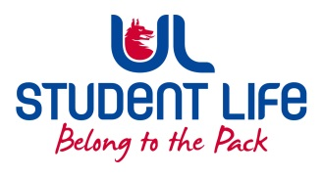
UL Student Life

EXECUTIVE COMMITTEE REPORT
President
Author | : | Alan Enright (Faculties Officer)
Date | : | 27/01/2022
Audience | : | Student Council
Action | : | Approve
Goals
Main Goals |  |  | Progress (what have you achieved since the last AGM)
 |  |  | To pinpoint areas where representation is lacking, will go through list of reps and documented what years and what courses are currently lacking representation.
Assess ongoing issues with FYP tutors.
 |  |  | Reached out to class reps and other council members in relation to current student representation methods and opinions on efficiency etc.
 |  |  | Determine a method of representation for students who aren’t taking prescribed courses and are picking their own subjects etc.
Other Achievements since last Council
 |  |  | Chairperson training
 |  |  | Facilitated move of lecture slots for certain courses within S & E to better suit students.
Attendance at events/meetings and actions taken or agreed
 |  |  | Student exec
Plans before the next meeting
Action/work area |  |  | What I hope to achieve
Student Engagement
Type of Engagement (Meeting, event etc) |  |  | Purpose and anything to report on
Media engagement and external relations
Engagement (Press, other organisations etc) |  |  | Purpose and anything to report on
 |  |  | n/a

