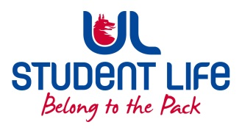
UL Student Life

STUDENT EXECUTIVE COMMITTEE REPORT
Role / Position | : | Equality and Diversity Chairperson
Author | : | Vivin Viswanath
Date | : | 27th January 2022
Audience | : | UL Student Council
Action | : | Draft
Goals
Main Goals |  |  | Progress (what have you achieved since the last Council meeting)
Pride week on Week#5 |  |  | Events and other activities being planned with Jordon.  Initial list of events prepared.  More ideas being discussed for event promotion
Other Achievements since last Council
Gender neuter toilets |  |  | Received the list of gender-neutral toilets present in campus from EDI team. Forwarded the same to councillors for spreading the awareness among students.
Attendance at events/meetings and actions taken or agreed
NA
Plans before the next meeting
Action/work area |  |  | What I hope to achieve
Pride Week |  |  | List of confirmed events, merc and activities for the Pride Week.
Student Engagement
NA
Media engagement and external relations
NA

