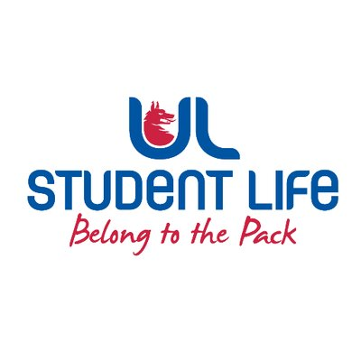
executive reports
UL STUDENT LIFE EXECUTIVE 2023/24
Role/Position: | Student Events Chairperson
Author: | Todor Aleksandrov
Date: | WK4 02/10/23

Goals This Week |  | Action Required?
Charity week | - Meet with events organisers re RAG week | Meeting
Class reps | - Go around campus recruiting reps | Recruitment
Committee Meeting Updates |  | Action Required?
Student council | Raised parking on campus as an issue | Agreed to follow up on it with Pres.
Updates since Last Council |  | Action Required?
Parking | Met with Ronan Cahill re Parking | Discussion
Meetings | Met with Events coordinators to see what’s coming up
Events | Helped out at Fresher’s Week with banding on Monday and Wednesday | Had a blast!
Student Engagement | Helped recruit class reps | N/A
Media and Public Relations | Appeared on the ULSL story!
Upcoming Plans: What I Hope to Achieve |  | Action
Merch | Push for some SC and executive merch | Advocate
Parking | Have a wider discussion about parking at SC | Add it to the agenda

