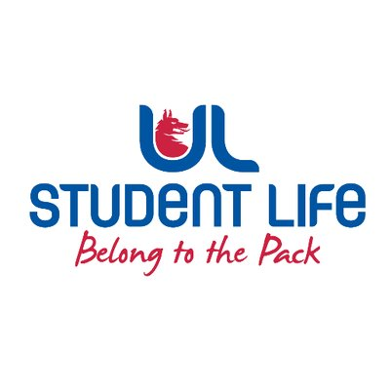
executive reports
UL STUDENT LIFE EXECUTIVE 2023/24
Role/Position: | Student Events Chairperson
Author: | Todor Aleksandrov
Date: | WK8 31/10/23

Goals This Week |  | Action Required?
Library | - Improve student experience in the Library | Meetings
Committee Meeting Updates |  | Action Required?
Student council | Raised Living Bridge lights as an issue | N/A
Updates since Last Council |  | Action Required?
Bridge | Collaborated with the Student President to fix the lights on the Living Bridge
Events | Organised and enjoyed an event for Student Council | N/A
Student Engagement | Helped recruit class reps | N/A
Upcoming Plans: What I Hope to Achieve |  | Action
Library | Resolve the numerous issues we’re facing | Agenda the issues and talk about them

