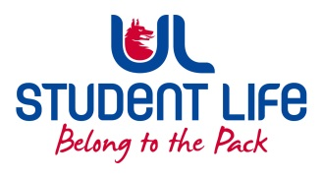
UL Student Life

STUDENT EXECUTIVE COMMITTEE REPORT
Role / Position | : | Student President
Author | : | Maeve
Date | : | 02/11/2022
Audience | : | UL Student Council Exec
Action | : | Approve
Goals
Main Goals |  |  | Progress (what have you achieved since the last Council meeting)
Governing Authority |  |  | Student Centre
Other Achievements since last Council
 |  |  | Microwaves
Attendance at events/meetings and actions taken or agreed
Sports Arena Board
Sports Arena Board Strategic Planning
PCC Board Strategic Planning
Healthy UL Meeting and Charter
Plans before the next meeting
Action/work area |  |  | What I hope to achieve
 |  |  | Fully planned demonstration!
Student Engagement
Type of Engagement (Meeting, event etc) |  |  | Purpose and anything to report on
 |  |  | Prepare for commuter hub semester 2
 |  |  | Demonstration Work: emails to Simon Harris, Solicitor
Media engagement and external relations
Engagement (Press, other organisations etc) |  |  | Purpose and anything to report on

