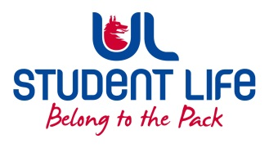
UL Student Life

STUDENT EXECUTIVE COMMITTEE REPORT
Role / Position | : | Events Chairperson
Author | : | Ronan Cahill
Date | : | 25/10/2022
Audience | : | UL Student Council
Action | : | Approve
Goals
Main Goals |  |  | Progress (what have you achieved since the last Council meeting)
Meeting with Welfare Officer |  |  | I met with Welfare officer Maeve Gilmore in which we had a chat discussing further my role and how we will both be interlinking throughout the year. This was very beneficial in learning more about my role and the rsponsibilities it entails. We also discussed the need to try and fill my third councillor position which is still currently vacant.
Robert Grace Gig in Stables |  |  | I was ticket scanning at the stables alongside our welfare officer Maeve Gilmore and Events Manager Dara for the Robert Grace gig in the stables recently which was a massive success. The stables was almost at full capacity which is highlighting the great work our events department is doing at organising suitable and interesting events to maximise student engagement. The event ran very smoothly and most importantly there was no trouble and everyone was safe.
Other Achievements since last Council
Attendance at events/meetings and actions taken or agreed
 |  |  | GA, Academic Council, faculty board meetings,
Plans before the next meeting
Action/work area |  |  | What I hope to achieve
Meet with councillors |  |  | Following this meeting I hope to gage contact with the current two relevant elected councillors in order to touch base, get to know each other and to start discussing some ideas for the year ahead and also to listen to any plans ideas or concerns they have.
Student Engagement
Type of Engagement (Meeting, event etc) |  |  | Purpose and anything to report on
Media engagement and external relations
Engagement (Press, other organisations etc) |  |  | Purpose and anything to report on

