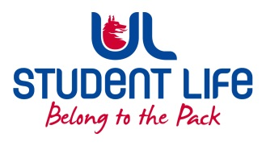
UL Student Life

STUDENT EXECUTIVE COMMITTEE REPORT
Role / Position | : | Student President
Author | : | Maeve
Date | : | 06/10/2022
Audience | : | UL Student Council Exec
Action | : | Approve
Goals
Main Goals |  |  | Progress (what have you achieved since the last Council meeting)
 |  |  | Got the meeting with Minister Harris: Met with Minister Harris and discussed many topics. Accommodation, GEMS, deferrals
 |  |  | Stables and Scholars: potential to re-tender
 |  |  | Lobby at the Governing Authority for free parking, more carpool spaces, highlight the potential for Park and Ride within surrounding areas
Other Achievements since last Council
Attendance at events/meetings and actions taken or agreed
 |  |  | GA, Academic Council, faculty board meetings,
Plans before the next meeting
Action/work area |  |  | What I hope to achieve
 |  |  | Establish my engagement strategy: pop in office hours
Student Engagement
Type of Engagement (Meeting, event etc) |  |  | Purpose and anything to report on
 |  |  | A few pop ins from students
Media engagement and external relations
Engagement (Press, other organisations etc) |  |  | Purpose and anything to report on
 |  |  | Mary I and USI networking

