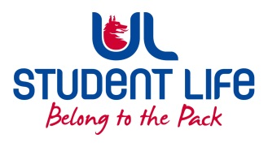
UL Student Life

STUDENT EXECUTIVE COMMITTEE REPORT
Role / Position | : | PSU Rep.
Author | : | Louis Pemble
Date | : | 06-10-22
Audience | : | UL Student Council
Action | :
Goals
Main Goals |  |  | Progress (what have you achieved since the last Council meeting)
Better Timetables |  |  | Met with Fintan Breen. WG has begun, consultation with stakeholders expected semester 2.
Student Accommodation |  |  | Met with new Accommodation Officer. Digs are very available but unsuitable for international students
Better Transport Links |  |  | Contact made with Limerick Council. Also attended public consultation calling for a new bus route to Castleconnell area. Suggestion made for temporary one way system on campus.
i-grade reform |  |  | Approved in principal at Academic Council
Funding for Eist |  |  | Decision on funding expected soon.
Other Achievements since last Council

Attendance at events/meetings and actions taken or agreed
C&S Council |  |  | Attended.
Plans before the next meeting
Action/work area |  |  | What I hope to achieve
Bus Route |  |  | Submit letter of support
Student Engagement
Type of Engagement (Meeting, event etc) |  |  | Purpose and anything to report on
SUSI |  |  | Met with various students confused about implications of the budget
Media engagement and external relations
Engagement (Press, other organisations etc) |  |  | Purpose and anything to report on
USI, Minister |  |  | Postgrad VP to meet with Minister Harris and USI.

