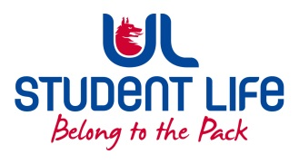
UL Student Life

STUDENT EXECUTIVE COMMITTEE REPORT
Role / Position | :
Author | : | Louis Pemble
Date | : | 21-9-22
Audience | : | UL Student Council
Action | :
Goals
Main Goals |  |  | Progress (what have you achieved since the last Council meeting)
Better Timetables |  |  | Following up with Fintan Breen
Student Accommodation |  |  | Discussion with GA, Exec, Faculties, and MIC.
Better Transport Links |  |  | Reaching out to Smarter Travel
i-grade reform |  |  | Due to meet Provost for update.
Funding for Eist |  |  | Under consideration by UL Exec.
Other Achievements since last Council

Breakfast Club |  |  | Free cereals and breakfast bar now in PSU.
MA Orientation |  |  | Worked with GPS to facilitate orientation on short notice, because of CAO issue.
Attendance at events/meetings and actions taken or agreed
EHS Faculty Board |  |  | There are now more PG students than UG in EHS
Plans before the next meeting
Action/work area |  |  | What I hope to achieve
Student Engagement
Type of Engagement (Meeting, event etc) |  |  | Purpose and anything to report on
Culture Night |  |  | Event in Millstream
Media engagement and external relations
Engagement (Press, other organisations etc) |  |  | Purpose and anything to report on
HEA Race Equality Launch |  |  | Attended launch of important policy, liased with TCDSU. TCDGUS, UCDSU. TUDSU

