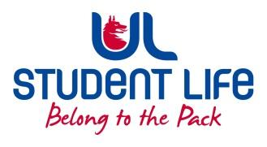
UL Student Life

STUDENT EXECUTIVE COMMITTEE REPORT
Role / Position | : | Experience Chairperson
Author | : | Maud Keane
Date | : | 20th October 2022
Audience | : | UL Student Council
Action | : | Approve
Goals
Main Goals |  |  | Progress (what have you achieved since the last Council meeting)
Meeting with Welfare Officer Maeve Gilmore |  |  | Attended a meeting with Welfare Officer Maeve Gilmore this week alongside Events Chairperson Ronan Cahill in order to discuss our roles, found this to be extremely beneficial in furthering my understanding of my role and responsibilities
Contact with Siobhán on the subject of Social Media work |  |  | I’ve been in contact with Siobhán regarding social media work for Student Life, with regard to recruitment and other such topics.
Other Achievements since last Council

N/A
Attendance at events/meetings and actions taken or agreed
Plans before the next meeting
Action/work area |  |  | What I hope to achieve
Contact Councillors |  |  | I plan on contacting my relevant councillors following this week’s student council meeting in order to touch base with them and start discussing ideas and plans of action with them and to hear any ideas they may have.
Student Engagement
Type of Engagement (Meeting, event etc) |  |  | Purpose and anything to report on
Media engagement and external relations
Engagement (Press, other organisations etc) |  |  | Purpose and anything to report on

