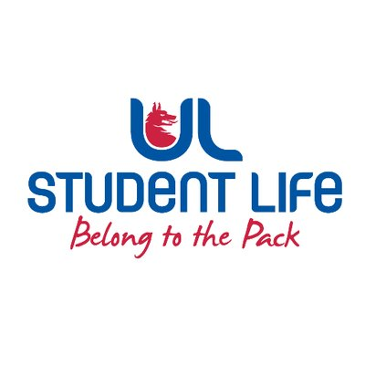
executive reports
UL STUDENT LIFE EXECUTIVE 2023/24
Role/Position: Faculties Officer
Author: Niamh Hickey
Date: | WK7 27/10/2023

Goals This Week |  | Action Required?
Exec | Bring agenda item to Exec | Exec Item
Committee Meeting Updates |  | Action Required?
n/a | n/a | n/a
Updates since Last Council |  | Action Required?
Rep Recruitment | Worked with Jasmine, Ronan M. and Andrew on rep recruitment strategies. | n/a
Student Engagement | Helping students get class reps for their class, especially if they’re a smaller class.  Ran NStEP training for class reps this week, really engaging, might get a few new councillors out of it | n/a
Meetings | Board of Directors Meeting
Upcoming Plans: What I Hope to Achieve |  | Action
Recruitment | Continuing to help recruitment reps, esp. department reps. | Help recruit more department reps.

