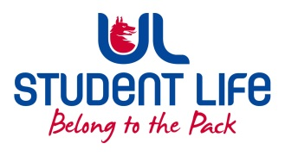
UL Student Life

STUDENT EXECUTIVE COMMITTEE REPORT
Role / Position | : | Faculties Officer
Author | : | Niamh Hickey
Date | : | 10/03/2022
Audience | : | UL Student Council Executive/UL Student Council
Action | : | Approve
Goals
Main Goals |  |  | Progress (what have you achieved since the last Council meeting)
Student Recruitment |  |  | - n/a
Student Training |  |  | - Met with Faculty Reps, discussed their roles
Student Feedback |  |  | - Encouraged people to vote  - Attended Hustings  - Worked in the Commuter Hub in Week 6
Other Achievements since last Council
Training |  |  | n/a
Attendance at events/meetings and actions taken or agreed
Meetings |  |  | - Not at Exec in Week 6 due to funeral, no Exec Week 7  - 1 Council meeting in Week 6
Events |  |  | Student Forum, LRO drop-ins, Commuter Hub
Plans before the next meeting
Action/work area |  |  | What I hope to achieve
Meetings |  |  | Discuss feedback from reps on the demonstration
Student Recruitment |  |  | Work with Siobhán, Jasmine, Kieran and Vivin on a strategy for recruitment of reps
Student Feedback |  |  | Help to act on the information given by students at the Student Forum
Student Engagement
Type of Engagement (Meeting, event etc) |  |  | Purpose and anything to report on
Event |  |  | n/a
Meeting |  |  | n/a
Media engagement and external relations
Engagement (Press, other organisations etc) |  |  | Purpose and anything to report on
Press |  |  | n/a

