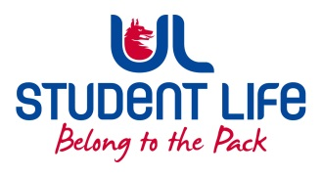
UL Student Life

STUDENT EXECUTIVE COMMITTEE REPORT
Role / Position | : | Faculties Officer
Author | : | Niamh Hickey
Date | : | 25/01/2022
Audience | : | UL Student Council Executive/UL Student Council
Action | : | Approve
Goals
Main Goals |  |  | Progress (what have you achieved since the last Council meeting)
Student Recruitment |  |  | - Met with Siobhán in January to discuss student recruitment/class rep recruitment.
Student Training |  |  | - NStEP training running this semester.
Student Feedback |  |  | - n/a
Other Achievements since last Council
Training |  |  | Exec Overnight! Training from 18th-19th of January with C&S Exec, great fun had!
Attendance at events/meetings and actions taken or agreed
Meetings |  |  | - 1 Further Student Executive meetings as of this report.  - Raised the issue of students being penalised for not attending classes.  - Raised the lack of facilities on campus  - 1 Council meeting in Week 12
Events |  |  | Attended multiple Commuter Hub Mornings
Plans before the next meeting
Action/work area |  |  | What I hope to achieve
Meetings |  |  | Discuss further the lack of facilities open over the weekend on campus & students being penalised over not attending lectures
Student Recruitment |  |  | Work with Siobhán, Jasmine, Kieran and Gillian on a strategy for recruitment of reps
Student Feedback |  |  | Help to act on the information given by students at the Student Forum
Student Engagement
Type of Engagement (Meeting, event etc) |  |  | Purpose and anything to report on
Event |  |  | n/a
Meeting |  |  | n/a
Media engagement and external relations
Engagement (Press, other organisations etc) |  |  | Purpose and anything to report on
Press |  |  | n/a

