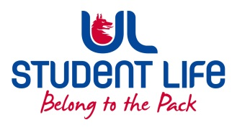
UL Student Life

STUDENT EXECUTIVE COMMITTEE REPORT
Role / Position | : | Student Council Chairperson
Author | : | Eoghan O’ Mahony
Date | : | 3-10-22
Audience | : | UL Student Council
Action | :
Goals
Main Goals |  |  | Progress (what have you achieved since the last Council meeting)
Student Council |  |  | Chaired my first Student Council meeting in week 4
Exec |  |  | Attended Exec in week 5 and 6
Hybrid Meeting Space |  |  | Worked with Siobhan on setting student council up in the meeting room using the teleconferencing software for full participation from all students.
Other Achievements since last Council

Attendance at events/meetings and actions taken or agreed
PSU AGM |  |  | Attended PSU AGM as an observer and provided feedback
Plans before the next meeting
Action/work area |  |  | What I hope to achieve
Student Engagement
Type of Engagement (Meeting, event etc) |  |  | Purpose and anything to report on
Media engagement and external relations
Engagement (Press, other organisations etc) |  |  | Purpose and anything to report on
Virgin Media / GORM |  |  | Spoke to Virgin Media / Gorm as a random student on the Housing issues in UL

