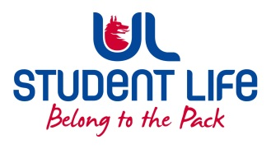
UL Student Life

STUDENT EXECUTIVE COMMITTEE REPORT
Role / Position | : | Student Council Chairperson
Author | : | Eoghan O’ Mahony
Date | : | 21-9-22
Audience | : | UL Student Council
Action | :
Goals
Main Goals |  |  | Progress (what have you achieved since the last Council meeting)
Recruitment Drive |  |  | I handed out leaflets in the courtyard and spoke with students interested in joining student council and class reps.
C&S Fair |  |  | I attened the Clubs and Societies fair with Student Life and promoted Student Council and Class Reps
Other Achievements since last Council

Board of Directors |  |  | I attended the ULSL Board of Directors meeting on the 11th of August
Attendance at events/meetings and actions taken or agreed
Plans before the next meeting
Action/work area |  |  | What I hope to achieve
Student Engagement
Type of Engagement (Meeting, event etc) |  |  | Purpose and anything to report on
Media engagement and external relations
Engagement (Press, other organisations etc) |  |  | Purpose and anything to report on

