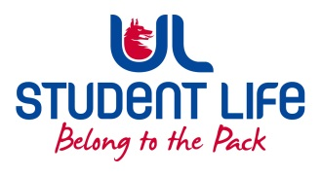
UL Student Life

STUDENT EXECUTIVE COMMITTEE REPORT
Role / Position | : | Student Academic
Author | : | Kieran
Date | : | 22/09/2022
Audience | : | UL Student Council Exec
Action | : | Approve
Goals
Main Goals |  |  | Progress (what have you achieved since the last Council meeting)
 |  |  | Learning centre collab
 |  |  | Working hard recruiting council/reps
Other Achievements since last Council
 |  |  | Beginning to work on a GYST Week.
 |  |  | Took part in tent talks.
Attendance at events/meetings and actions taken or agreed
 |  |  | APRC, SLOS, EHS Faculty board, WG on student feedback mechanisms.
Plans before the next meeting
Action/work area |  |  | What I hope to achieve
 |  |  | Good relationships with Learning centres
 |  |  | Get as many class reps/ council members as possible.
Student Engagement
Type of Engagement (Meeting, event etc) |  |  | Purpose and anything to report on
 |  |  | Pop Ups in the Courtyard
 |  |  | Clubs and Socs Fair
Media engagement and external relations
Engagement (Press, other organisations etc) |  |  | Purpose and anything to report on
 |  |  | N/A

