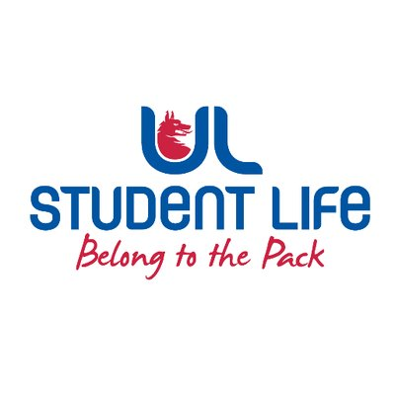
executive reports
UL STUDENT LIFE EXECUTIVE 2023/24
Role/Position: | Communities Officer
Author: | Katie Martin
Date: | WK3 27/9/23

Goals This Week |  | Action Required?
Campus Accessibility | - Voicing student concerns with high-university staff via the Student President | Send any accessibility issues you come across to Katie
Sensory Hour | - Purchased sensory aids and furniture for a weekly sensory hour in room 3  - Sponsorship requests | Looking for volunteers!
Student Parent Supports | - Review draft EDI Policy  - Assist student group with breastfeeding-friendly campus initiative | N/A
Committee Meeting Updates |  | Action Required?
C&S Council | Chaired first meeting  New C&S Executive elected  Great engagement | Introduce Clubs and Socs Officers
LGBTQI+ Network | Elected to the committee  Aim to connect students with the network for collaborations, events and training | N/A
Ukrainian Student Group | Applications open for funding towards supporting Ukrainian students | Suggestions welcome
Updates since Last Council |  | Action Required?
Training | ULFM | Tune into Officer Hour on Fridays 2-3pm
Awards | Represented Student Life at Leadership Awards in Naas | N/A
Events | Helped out at Fresher’s Week | Always looking for fun social media ideas
Student Engagement | Attended C&S Fair | Check out the reel on Instagram
Upcoming Plans: What I Hope to Achieve |  | Action
Demonstration | Host poster-making session with other officers and exec  Attend Cost of Living Protest on Saturday | Join us!
Communities Catch-up | Launch a space for bi-weekly meetings with different community groups. | Spread the word!

