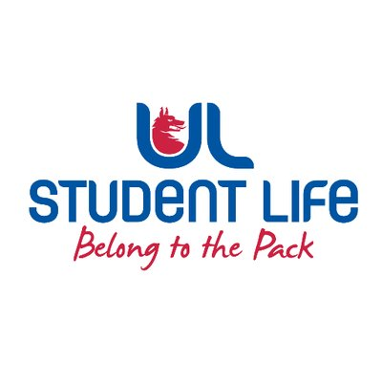
executive reports
UL STUDENT LIFE EXECUTIVE 2023/24
Role/Position: | Communities Officer
Author: | Katie Martin
Date: | WK7 26/10/23

Goals This Week |  | Action Required?
Rainbow Week | - Meet with OutInUL to finalise plans and start working on comms  - AMUL prep with other Officers | Decorate SU and common room with Pride flags
Sensory Hour | - Change to Tuesdays 1-2  - Plan Halloween-themed sensory hour on 31st  - Develop social media and marketing plan with Comms department | Looking for volunteers!  Spooky decorations
Communities Catch-up | - Meet with Sanctuary students for lunch and a meaningful conversation space | Buy Pizzas!
Ethnic Diversity Forum - Panel Discussion | - Suggest x2 students to speak on a panel  - Help with organising the event | Social media
Committee Meeting Updates |  | Action Required?
Ukrainian Support | Awaiting approval of funding proposals  Pushed for the continuation of the committee post-funding approvals to support students through their studies | N/A
LGBTQI+ Network | Promoted world pronouns day training on Instagram  Working with EDI on developing pride lanyards | N/A
C&S Council | Working with C&S to update the student body on the new student centre | Lots of content
C&S Exec | Developing equipment tracking and management system  Re-introducing Exec peer-to-peer drop-ins, following the success last year  Consultation on clubs and societies proposals for approval at C&S Council | N/A
Updates since Last Council |  | Action Required?
Cooking Demonstration | 3rd instalment of the Wellbeing Series, planning a cooking demo in the Pavillion | N/A
Sensory Hour | UL President, Kerstin May asked to visit the Sensory Room | N/A
Upcoming Plans: What I Hope to Achieve |  | Action
Connecting Communities | Connecting students from various communities to work together and share experiences | N/A

