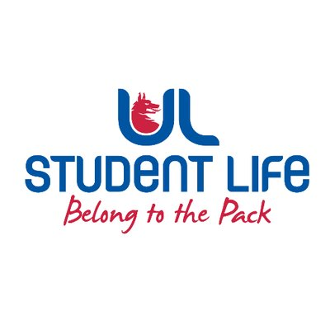
executive reports
UL STUDENT LIFE EXECUTIVE 2023/24
Role/Position: | Communities Officer
Author: | Katie Martin
Date: | WK5 12/10/23

Goals This Week |  | Action Required?
Start planning Rainbow Week | - Working with OutInUL and the Events team to plan a week of events and celebrations for the LGBTQI+ community | Create plan of action
Sensory Hour | - Submitting proposals for sensory hour funding  - Collaborate with University departments to spread the word and signpost students | Looking for volunteers!
Student Parent Supports | - Meet with EDI to discuss policy and supports  - Gain a greater understanding of academic procedures for pregnant students and parents | N/A
Committee Meeting Updates |  | Action Required?
C&S Exec | Chaired first executive meeting  Developing policy, approving new C&S proposals | N/A
LGBTQI+ Network | Working on plans for World pronouns day – training, events, Rainbow Week, pride lanyards and pins | N/A
Ukrainian Student Group | Submit funding proposals | N/A
Updates since Last Council |  | Action Required?
World Mental Health Day | Positive affirmations QR code in student centre and at C&S council | Always looking for fun social media ideas
Student Parents Library Use | Working with Academic Officer to investigate the possibility of student parents bringing children with them to study rooms on weekends | N/A
Upcoming Plans: What I Hope to Achieve |  | Action
Communities Catch-up | Continue meeting students from different community groups and developing networks | Spread the word!

