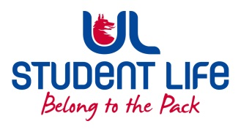
UL Student Council 2021 / 22
Meeting 5

Agenda
 | Meeting | : | UL Student Life Council
 | Date | : | November 23rd 2021 (Semester 1 - Week 12)
 | Venue | : | Zoom
 | Time | : | 6pm
Members: Cillian O’ Donohue, Alice Hynes, Jordan Cassells, Seán Ó’ Maoilchiaráin, Rania Shadeed; Louis Pemble; Cían Ó’ Caoinleáin; Vishal Manuhar; Alan Enright; Deepak Venkatasuresh; Vivin Viswanath; Darren Heffernan; Karan Gupta; Denver Joseph Saldanha; Emily Timmins; Edel Straum; Ben Fitzgerald Kiely;
Izzabella Parkinson; Joe Drennan; Jeremy Pili; Mary O’ Donnell; Eoghan O’ Mahony; Karin Mason; Ahana Maharaj; Clodagh Campion; Sushmita Biswas; Manoj Aggarwal; Achran Jain; Prateek Singh Patel; Yi Qin Gan; Melwin Mathew; Abaigéal Drummy; James Conner; Eadaoin Keyes; Sherin Thomas Emmatty.

In Attendance: Gillian O’ Gorman; Siobhán Wilmott; John McDermott.

Apologies:

No. | Items |  |  |  | Responsible | Time Allocation
 | Welcome to New Members |  |  |  | Cían
1. | Minutes and Matters Arising  Minutes of Council Meeting – 9th November |  |  |  | Cían | 5 Mins
2. | Meeting Business
a. | Executive Reports |  |  |  | Exec | 15 mins
b. | Mental Health Survey Results |  |  |  | Seán | 10 mins
c | Motion Vote – Installation of Gates (KBS & Schumann) |  |  |  | Cillian | 10 mins
 | AOB
Duration: 40 minutes Next Meeting: 1st February 2022

